Unit 4: Energy
Topic: Energy change

Name: ______________________

Class: __________________( )

Date: ________________________

Teacher Demonstration
Teacher makes use of the following materials to construct a setup.
Ball × 1 Wooden block × 1
Track × 1 Stand and clamp × 1
Position A
Position B
Teacher now holds the ball at position A.
- The ball carries ___potential__ energy because position A is _____higher____ than position B.
- When the ball is released at position A, the ball rolls down to position B. The _potential__ energy of the ball changes into __kinetic__ energy.
Now teacher releases the ball from position A, observe carefully.
- Is there any other energy conversions?
Some energy is lost as heat and sound because of the friction of the track.

- Use Sankey diagram to show the energy change of the above experiment.
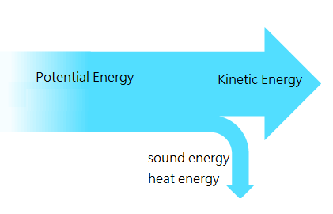

Task 1: Design a process that can involve two or more energy conversions.
Now your group is given the same kind of materials. Please design a setup that involves two or more energy conversions.

- Draw and label your design below.
2. Describe the energy conversion of your setup.

- Use Sankey diagram to show the energy change of the above experiment.
Task 2 : Design a process that can involves three to five energy conversions.

Students are given various apparatus.
Track  Ball  Rubber band | Electric fan  Balloon  Torch | Stand and clamp  Dominos  metal strip

Design a setup that involves three to five energy conversions by making use of the above apparatus. It is not necessary to use all the apparatus. Label the diagram.
Describe the energy conversions of your setup.

Write down the comments from your classmates after your presentation.

Teaching Notes
Sample of process involving three or more energy conversions

ball

Dominos
Track
Dominos

Metal strip

Describe the energy conversions of the sample
When the ball rolls down the track, its potential energy changes into kinetic energy.
Then the ball hits on dominos, the kinetic energy of the ball will pass to become the kinetic energy of the dominos. When the dominos fall down, potential energy of dominos changes into kinetic energy. When the domino hit metal strip, the kinetic energy changes into sound energy.

Which part of the setup is useful in your daily life? Briefly describe how you would use it.

Assessment:
Area
Creative and practical setup | /5
Communication of scientific knowledge | /5
Total: | /10

